Given a non-negative integer num, Return its *encoding* string.

The encoding is done by converting the integer to a string using a secret function that you should deduce from the following table:

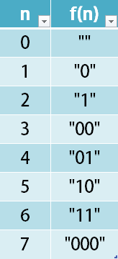

**Example 1:**

**Input:** num = 23

**Output:** "1000"

**Example 2:**

**Input:** num = 107

**Output:** "101100"

**Constraints:**

* 0 <= num <= 10^9